Thesis Title replace this text with your own
Author’s Name replace this text with your own
A Senior Thesis Submitted to the Department of Art and Archaeology, Princeton University, in Partial Fulfillment of the Requirements for the Degree of Bachelor of Arts
Princeton, New Jersey
Date enter the date
Pledge
This thesis represents my own work in accordance with University regulations.
DELETE THIS LINE Sign your name beneath the pledge.

Table of Contents – never type or change formatting on this page – just right click anywhere below and choose to update entire table
Introduction: Why Use a Template? 1
Don’t like this font? 1
Chapter 1 Combining Chapters 3
So you have subtitles? 3
What if my subtitle falls at the bottom of my page? 3
Pasting in Text 4
You have questions, I have answers 4
The last thing 4
Chapter 2 How Avengers is just like Oedipus 5
Filler Text Below 5
Chapter 3 Chapter Headings should start a new page 7
Conclusion 9
Bibliography 11

Acknowledgements (optional):

List of Illustrations – never type or change formatting here – just right click anywhere bel below and choose to update field
Figure 1 Delete the image above. Use Insert> Picture from file (will be different if using a PC Insert, Pictures – do not copy/paste) After this caption is replaced, there needs to be a page break. Every image /caption pair should have a page break afterwards
Figure 2 After I type this caption I will add a page break
Figure 3 Notice that in the Styles pane there is a style for caption. Use it to change the font and style of all the captions at the same time.
Figure 4 If an image comes in to big for the page, right clock and choose size, set one dimension and the other will change, but maintains aspect ratio
Figure 5 Michelangelo, David, 1501-3, marble, 5.17 m high. Accademia Gallery, Florence. Photograph from ArtStor, http://www.artstor.org, accessed Aug. 15, 2006.

Introduction: Why Use a Template?
The number one reason to choose to use this template is for the page numbering! But there are other reasons too. This template will make your table of contents for you as well as your list of illustrations. Turn on the Pilcrow so you can SEE the formatting, the page breaks, the styles: 

Don’t like this font?
If you do not like this font there is ONLY ONE PLACE to change it correctly: Go to the styles pane. (Alt Ctrl Shift S) Hover to the right of the word Normal to get the down arrow. Choose Modify Style, then change your font to whatever you like. You will see this entire template change to the font you chose. Use Control Z to undo if you hate it, then try again.
This is where you will type your text! You should NEVER use the TAB button to indent. Instead, try going to Format, Paragraph and choose Indent first line. Notice the “After” spacing to 12 points. Now every time you hit enter to go to a new paragraph, it will be spaced by 12 points and it will indent automatically! (I have already set paragraph indenting for you).
You should never ever hit the enter key over and over to add space. By setting the paragraph spacing from the get-go – which I have done for this template – your paragraphs will be spaced correctly. You should be typing your paper here. In this document. Students typically do one chapter at a time in separate files – and you can do that if you want – in that case you DO NOT COPY AND PASTE ENTIRE CHAPTERS into this document. Instead, put the cursor where you want it , Insert a page break, and then choose Insert, File.
Chapters should get a page break between them. That way they start at the top of a page, regardless of how you move paragraphs around as you are writing your paper.

Chapter 1 Combining Chapters
Students typically make one file for each chapter and then combine them. That is fine – it keeps the paper from becoming too bulky. But you should use this template anyway. Just delete the beginning pages that you do not need.
Important: when you go to combine chapters, do NOT copy and paste from one file to the main document – this could change the formatting of things like footnotes. To combine your chapters, start with this main document. Go to where you want to insert a chapter. First Insert a page break, then choose Insert, File.

So you have subtitles?
If you use subtitles, they should have Heading 2 applied and they will show up indented in the Table of Contents. The table of contents that already exists in this paper can stay there. All you have to do is right click on it and choose Update > Update Entire table. Then any changes you have made will go there automatically.

What if my subtitle falls at the bottom of my page?
The headings have been designed to use “Keep With Next” – but if you have something else splitting across pages that you want to stay together, highlight the text, go to Format, Paragraph, look for the Tab that says :Line and Page Breaks, then choose Keep Lines Together and/or Keep with Next (experiment to what works)

Pasting in Text
When you paste in text and it doesn’t look the way you want it to – whether it be a spacing or a font issue – highlight the text, then go to the styles pane and choose Normal. The styles pane should always be open (Alt Ctrl Shift S).

You have questions, I have answers
Email me at angarone@princeton.edu if you have any questions. I will either send you screen shots and explicit formatting solutions, or you can request a one-on-one meeting with me.

The last thing
The last thing to do – but you can do it anytime – go to the table of contents, right click in it, choose Update Field > Update Entire table. In the list of Illustrations, do not type there, simply right-click and choose to update the field.

Chapter 2 How Avengers is just like Oedipus
This is where chapter two text will go. After the title, but before the page break.

Filler Text Below
Lorem ipsum dolor sit amet, consectetur adipiscing elit. Nulla nec est ac elit vulputate hendrerit. Phasellus rhoncus efficitur tincidunt. Cras vulputate enim sed nisi commodo lacinia sit amet ut lorem. Aliquam finibus dapibus laoreet. Vivamus maximus leo vitae dui accumsan sollicitudin. Aliquam at enim vitae dui suscipit bibendum. Maecenas eu nisi ut leo vehicula imperdiet. Phasellus eu pharetra tortor, a sagittis diam. Aliquam sollicitudin orci ligula, in elementum augue consequat ut. Aliquam congue magna eu arcu fringilla pulvinar. Integer porta cursus dolor et pulvinar. Mauris lorem ligula, vehicula eu lectus vitae, hendrerit elementum est. Donec porta tortor quis metus pulvinar, et condimentum sem tincidunt. Duis quam elit, accumsan non ipsum quis, convallis porta ante. Nulla erat ligula, feugiat et quam vel, laoreet molestie arcu.
Aenean feugiat pharetra ante, dictum sagittis magna suscipit eget. Morbi dictum sodales elit, non sollicitudin libero feugiat in. Duis justo odio, ultrices vitae tempus ut, pulvinar id arcu. Donec faucibus finibus tincidunt. Suspendisse suscipit convallis libero, non condimentum mauris cursus quis. Ut mattis vel ligula quis condimentum. Etiam non sollicitudin dolor.
Mauris blandit non tortor condimentum facilisis. Nullam risus tortor, dictum in consequat nec, sollicitudin vitae est. Donec dapibus tortor id egestas interdum. Aliquam vestibulum hendrerit maximus. Sed non congue ligula, ac vestibulum ligula. Etiam iaculis in nisi a placerat. Ut mattis orci ut sapien varius, eget ultricies nisi imperdiet. Vivamus mollis tincidunt eros, et condimentum purus auctor non. Donec feugiat libero justo, in facilisis enim eleifend nec.
Donec eget elit et mauris ultrices dapibus. Aliquam et orci a orci rhoncus viverra in eget lectus. Aenean facilisis tincidunt nisi. Etiam sodales porttitor quam non aliquet. Praesent iaculis imperdiet justo non aliquam. Phasellus vel sagittis ex. Vestibulum placerat lacus vitae magna porta interdum. Suspendisse gravida vel magna eget gravida. Nullam sit amet arcu vel lorem egestas varius nec eu quam. Fusce nec vulputate ex, vel tempus ante. Proin ac commodo mauris, at porta est.
Vestibulum ac dui elit. Sed vitae nisl ut ante tempor gravida a vel sapien. Mauris molestie ut nulla vitae feugiat. Sed facilisis eleifend erat, sed ultrices justo finibus sed. In hac habitasse platea dictumst. Maecenas et neque laoreet, lacinia mauris eu, scelerisque ligula. Maecenas ultrices sem eget dolor iaculis, et dapibus elit laoreet. Quisque commodo nibh nisl, at ornare ante pulvinar ut. Nulla porttitor purus id eros pellentesque, in scelerisque ligula rhoncus. Maecenas posuere ligula elit, ut pharetra arcu interdum eu.

Chapter 3 Chapter Headings should start a new page
Lorem ipsum dolor sit amet, consectetur adipiscing elit. Nulla nec est ac elit vulputate hendrerit. Phasellus rhoncus efficitur tincidunt. Cras vulputate enim sed nisi commodo lacinia sit amet ut lorem. Aliquam finibus dapibus laoreet. Vivamus maximus leo vitae dui accumsan sollicitudin. Aliquam at enim vitae dui suscipit bibendum. Maecenas eu nisi ut leo vehicula imperdiet. Phasellus eu pharetra tortor, a sagittis diam. Aliquam sollicitudin orci ligula, in elementum augue consequat ut. Aliquam congue magna eu arcu fringilla pulvinar. Integer porta cursus dolor et pulvinar. Mauris lorem ligula, vehicula eu lectus vitae, hendrerit elementum est. Donec porta tortor quis metus pulvinar, et condimentum sem tincidunt. Duis quam elit, accumsan non ipsum quis, convallis porta ante. Nulla erat ligula, feugiat et quam vel, laoreet molestie arcu.
Aenean feugiat pharetra ante, dictum sagittis magna suscipit eget. Morbi dictum sodales elit, non sollicitudin libero feugiat in. Duis justo odio, ultrices vitae tempus ut, pulvinar id arcu. Donec faucibus finibus tincidunt. Suspendisse suscipit convallis libero, non condimentum mauris cursus quis. Ut mattis vel ligula quis condimentum. Etiam non sollicitudin dolor.
Mauris blandit non tortor condimentum facilisis. Nullam risus tortor, dictum in consequat nec, sollicitudin vitae est. Donec dapibus tortor id egestas interdum. Aliquam vestibulum hendrerit maximus. Sed non congue ligula, ac vestibulum ligula. Etiam iaculis in nisi a placerat. Ut mattis orci ut sapien varius, eget ultricies nisi imperdiet. Vivamus mollis tincidunt eros, et Donec eget elit et mauris ultrices dapibus. Aliquam et orci a orci rhoncus viverra in eget lectus. Aenean facilisis tincidunt nisi. Etiam sodales porttitor quam non aliquet. Praesent iaculis
Donec eget elit et mauris ultrices dapibus. Aliquam et orci a orci rhoncus viverra in eget lectus. Aenean facilisis tincidunt nisi. Etiam sodales porttitor quam non aliquet. Praesent iaculis imperdiet justo non aliquam. Phasellus vel sagittis ex. Vestibulum placerat lacus vitae magna porta interdum. Suspendisse gravida vel magna eget gravida. Nullam sit amet arcu vel lorem egestas varius nec eu quam. Fusce nec vulputate ex, vel tempus ante. Proin ac commodo mauris, at porta est.
Vestibulum ac dui elit. Sed vitae nisl ut ante tempor gravida a vel sapien. Mauris molestie ut nulla vitae feugiat. Sed facilisis eleifend erat, sed ultrices justo finibus sed. In hac habitasse platea dictumst. Maecenas et neque laoreet, lacinia mauris eu, scelerisque ligula. Maecenas ultrices sem eget dolor iaculis, et dapibus elit laoreet. Quisque commodo nibh nisl, at ornare ante pulvinar ut. Nulla porttitor purus id eros pellentesque, in scelerisque ligula rhoncus. Maecenas posuere ligula elit, ut pharetra arcu interdum eu.

Conclusion
Lorem ipsum dolor sit amet, consectetur adipiscing elit. Nulla nec est ac elit vulputate hendrerit. Phasellus rhoncus efficitur tincidunt. Cras vulputate enim sed nisi commodo lacinia sit amet ut lorem. Aliquam finibus dapibus laoreet. Vivamus maximus leo vitae dui accumsan sollicitudin. Aliquam at enim vitae dui suscipit bibendum. Maecenas eu nisi ut leo vehicula imperdiet. Phasellus eu pharetra tortor, a sagittis diam. Aliquam sollicitudin orci ligula, in elementum augue consequat ut. Aliquam congue magna eu arcu fringilla pulvinar. Integer porta cursus dolor et pulvinar. Mauris lorem ligula, vehicula eu lectus vitae, hendrerit elementum est. Donec porta tortor quis metus pulvinar, et condimentum sem tincidunt. Duis quam elit, accumsan non ipsum quis, convallis porta ante. Nulla erat ligula, feugiat et quam vel, laoreet molestie arcu.
Aenean feugiat pharetra ante, dictum sagittis magna suscipit eget. Morbi dictum sodales elit, non sollicitudin libero feugiat in. Duis justo odio, ultrices vitae tempus ut, pulvinar id arcu. Donec faucibus finibus tincidunt. Suspendisse suscipit convallis libero, non condimentum mauris cursus quis. Ut mattis vel ligula quis condimentum. Etiam non sollicitudin dolor.
Mauris blandit non tortor condimentum facilisis. Nullam risus tortor, dictum in consequat nec, sollicitudin vitae est. Donec dapibus tortor id egestas interdum. Aliquam vestibulum hendrerit maximus. Sed non congue ligula, ac vestibulum ligula. Etiam iaculis in nisi a placerat. Ut mattis orci ut sapien varius, eget ultricies nisi imperdiet. Vivamus mollis tincidunt eros, et condimentum purus auctor non. Donec feugiat libero justo, in facilisis enim eleifend nec.
Donec eget elit et mauris ultrices dapibus. Aliquam et orci a orci rhoncus viverra in eget lectus. Aenean facilisis tincidunt nisi. Etiam sodales porttitor quam non aliquet. Praesent iaculis imperdiet justo non aliquam. Phasellus vel sagittis ex. Vestibulum placerat lacus vitae magna porta interdum. Suspendisse gravida vel magna eget gravida. Nullam sit amet arcu vel lorem egestas varius nec eu quam. Fusce nec vulputate ex, vel tempus ante. Proin ac commodo mauris, at porta est.
Vestibulum ac dui elit. Sed vitae nisl ut ante tempor gravida a vel sapien. Mauris molestie ut nulla vitae feugiat. Sed facilisis eleifend erat, sed ultrices justo finibus sed. In hac habitasse platea dictumst. Maecenas et neque laoreet, lacinia mauris eu, scelerisque ligula. Maecenas ultrices sem eget dolor iaculis, et dapibus elit laoreet. Quisque commodo nibh nisl, at ornare ante pulvinar ut. Nulla porttitor purus id eros pellentesque, in scelerisque ligula rhoncus. Maecenas posuere ligula elit, ut pharetra arcu interdum eu.

Bibliography
DELETE the following Bold text and the image: I left an empty spot after the first citation (turn on your pilcrow to see it) . That spot already has the Hanging Indent applied – you can just type your first citation there and it will automatically indent the second line of your citation. Hit Enter and the next paragraph will also have a hanging indent applied. Delete all my other citations. If you somehow aren’t able to keep my formatting: To make a hanging indent, you go to Format, Paragraph, and choose Hanging Indent. There is a SECTION break at the end of the bibliography so that the Illustrations section which follows will not have page numbers (it isn’t supposed to)
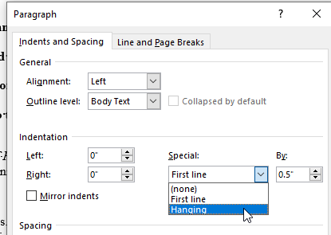
---. The Life of Forms in Art. Trans. Charles Beecher Hogan and George Kubler. New Haven: Yale University Press, 1942.

Barber, Charles. Contesting the Logic of Painting: Art and Understanding in Eleventh-Century Byzantium. Leiden and Boston: Brill, 2007.
Baxandall, Michael. “The Language of Art History.” New Literary History 10 (1979): 453-65.
Benjamin, Walter, The Work of Art in the Age of Its Mechanical Reproducibility, and Other Writings on Media. Edited by Michael Jennings, Brigid Doherty, and Thomas Y Levin. Translated by Edmund Jephcott, et al. Cambridge, Mass: Belknap Press, 2008.
Brody, Bertha. “Illegal Immigrant Sculptor Allowed to Stay.” New York Times, 4 July 1994. A12.
Exchange in 1879.” nonsite. Dec. 15, 2014. http://nonsite.org/article/capital-in-the-nineteenth-century (accessed Jan. 13, 2015).
Focillon, Henri. Giovanni Battista-Piranesi, 1720-1778. Paris: H. Laurens, 1918.
Foster, Hal. “Preposterous Timing.” Review of Medieval Modern: Art Out of Timeby Alexander Nagel. London Review of Books 34:21 (Nov. 8, 2012): 12-14.
Foster, Hal. “Preposterous Timing.” Review of Medieval Modern: Art Out of Time by Alexander Nagel. London Review of Books. Nov. 8, 2012. http://www.lrb.co.uk/v34/n21/hal-foster/preposterous-timing (accessed May 4, 2015).
Hacker, Diana. A Pocket Style Manual. 3rd ed. Boston: Bedford/St. Martin’s, 2000.
Noack, Dieter and Lilian. “DR Number 131.” The Daumier Register.
Rosenfield, John M., and Elizabeth ten Grotenhuis. Journey of the Three Jewels: Japanese Buddhist Paintings from Western Collections. New York: Asia Society, 1979.
Stewart, Susan. “Death and Life, in that Order, in the Works of Charles Willson Peale.” In Visual Display: Culture Beyond Appearances. Edited by Lynne Cooke and Peter Wollen, 31-53. Seattle: Bay Press, 1995.
The Metropolitan Museum of Art. “Timelines: 1600-1800 A.D.” Heilbrunn Timeline of Art History. http://www.metmuseum.org/toah/intro/atr/09sm.htm (accessed Dec. 4, 2011).
Young, Marnin. “Capital in the Nineteenth Century: Edgar Degas’s Portraits at the Stock

Illustrations (Insert Picture, then right click on picture and choose Insert Caption)
Your images should all be stored on your computer. But their file size will increase the file size of your paper. I suggest making screen shots of your images, and inserting the screenshots – this will make the paper file size easier to work with, and if you use screen shot when they fill your screen, they should have decent enough resolution for the thesis
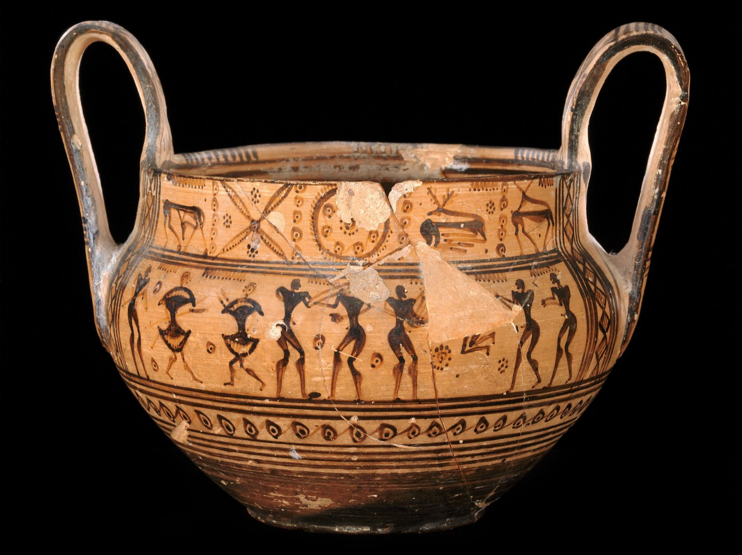
Figure 1 Delete the image above. Use Insert> Picture from file (will be different if using a PC Insert, Pictures – do not copy/paste) After this caption is replaced, there needs to be a page break. Every image /caption pair should have a page break afterwards

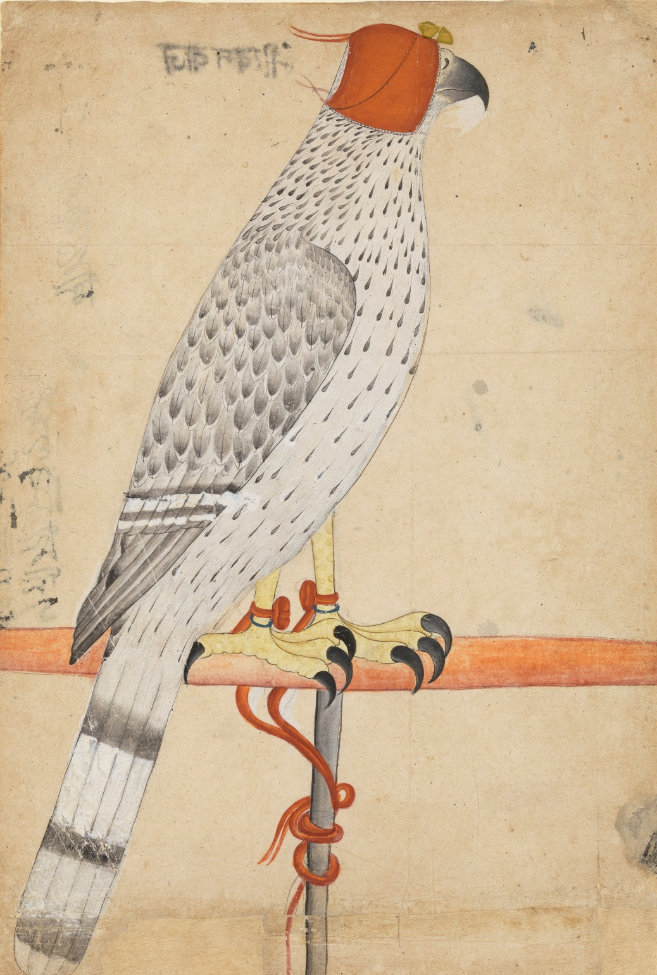
Figure 2 After I type this caption I will add a page break

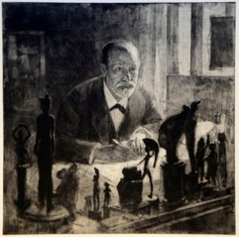
Figure 3 Notice that in the Styles pane there is a style for caption. Use it to change the font and style of all the captions at the same time.

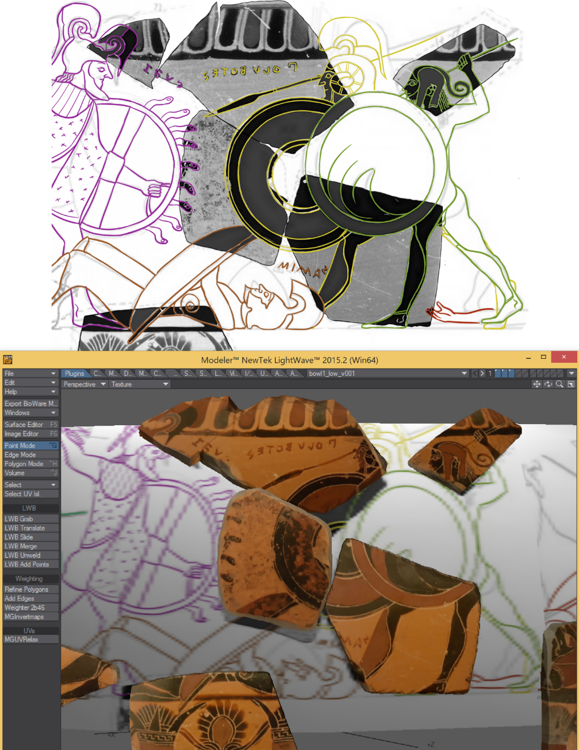
Figure 4 If an image comes in too large for the page, right click and choose size, set one dimension and the other will change automatically maintaining aspect ratio

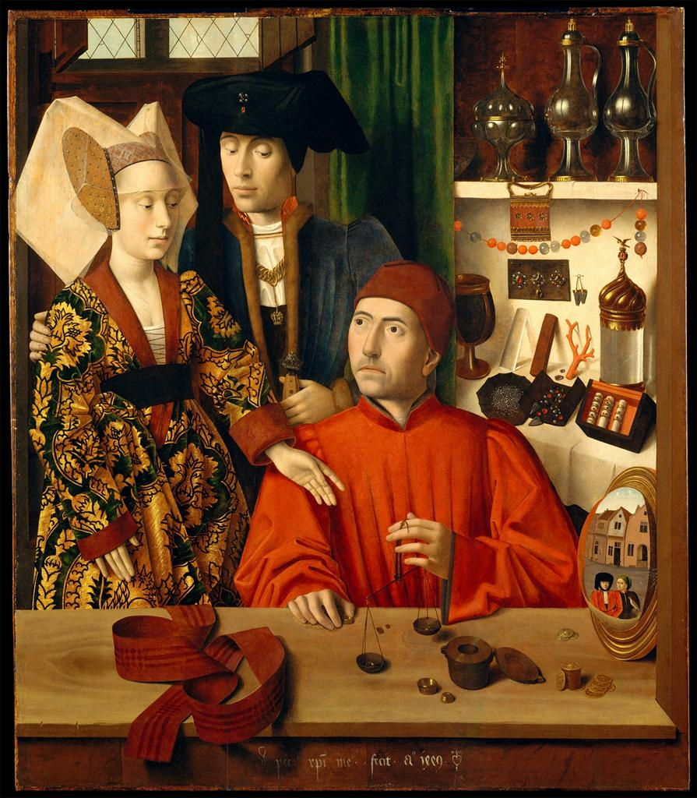
Figure 5 Michelangelo, David, 1501-3, marble, 5.17 m high. Accademia Gallery, Florence. Photograph from ArtStor, http://www.artstor.org, accessed Aug. 15, 2006.

You should be using footnotes, not endnotes. To insert a footnote in Word, choose the References tab and Insert Footnote. On a Mac, use the top menu to choose Insert, Footnote. Footnote formatting (font and spacing) is also controlled by the styles panel

